

**Final Project Phase 2**

Makenzie Howard, Vidhi Arun Sharma, Willie Watts, Alissa Yang

MET AD 599S O2 - Introduction to Python and SQL for Business Analytics

August 12, 2025

**Table of Contents**

Introduction 3

Part 1: Employee Sales Performance Analysis 3

Part 2: Monthly Sales Trend Analysis 4

Part 3: Product Sales Ranking by Category 5

Part 4: Customer Purchase Behavior Analysis 7

Conclusion 8

Appendices 9

# 

# **Introduction**

This report analyzes Northwind’s sales performance using SQL in Python to identify strategies across four key areas: employee performance, monthly sales trends, product sales ranking, and customer purchasing behavior. The findings reveal a consistently performing sales team with opportunities to boost results, seasonal peaks tied to holidays, high-margin products driving revenue despite lower unit sales, and customer segments requiring engagement strategies. These insights provide data-driven strategies to align marketing and inventory for Northwind’s profitability year-round.

# **Part 1: Employee Sales Performance Analysis**

To identify top-performing employees based on their total sales, we calculated the total sales amount for each employee. The query calculates the total sales generated by each employee by summing the sales values of their orders and takes into account quantity and discounts while ranking their performance in descending order.

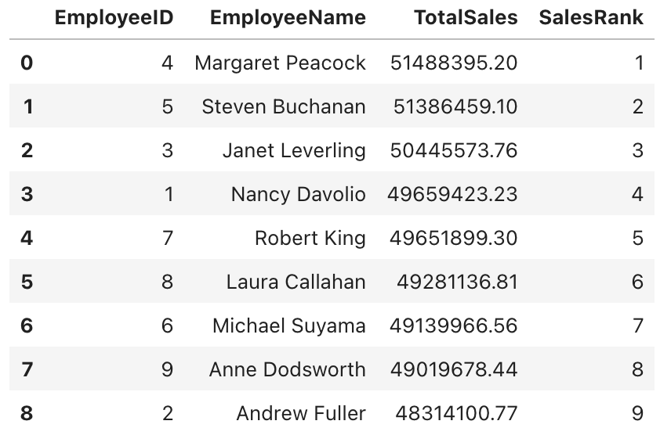

The overall sales distribution is relatively close with no extreme underperformance. This suggests that we are either working with a highly effective sales team or that territory potential is not a factor in total sales. Overall, there is roughly a $3million difference between the top performer and the lowest performer. Although there is rather consistent performance across all employees, small differences do add up in total revenue. Margaret Peacock and Steven Buchanan are our top 2 performers with very close total sales, so their sales tactics should be further analyzed to apply to the rest of the team in an effort to make up for any differences in performance and revenue. Furthermore, allowing for different incentive programs, such as a competition based program, could also make a difference in overall productivity as well by closing the performance gaps even further.

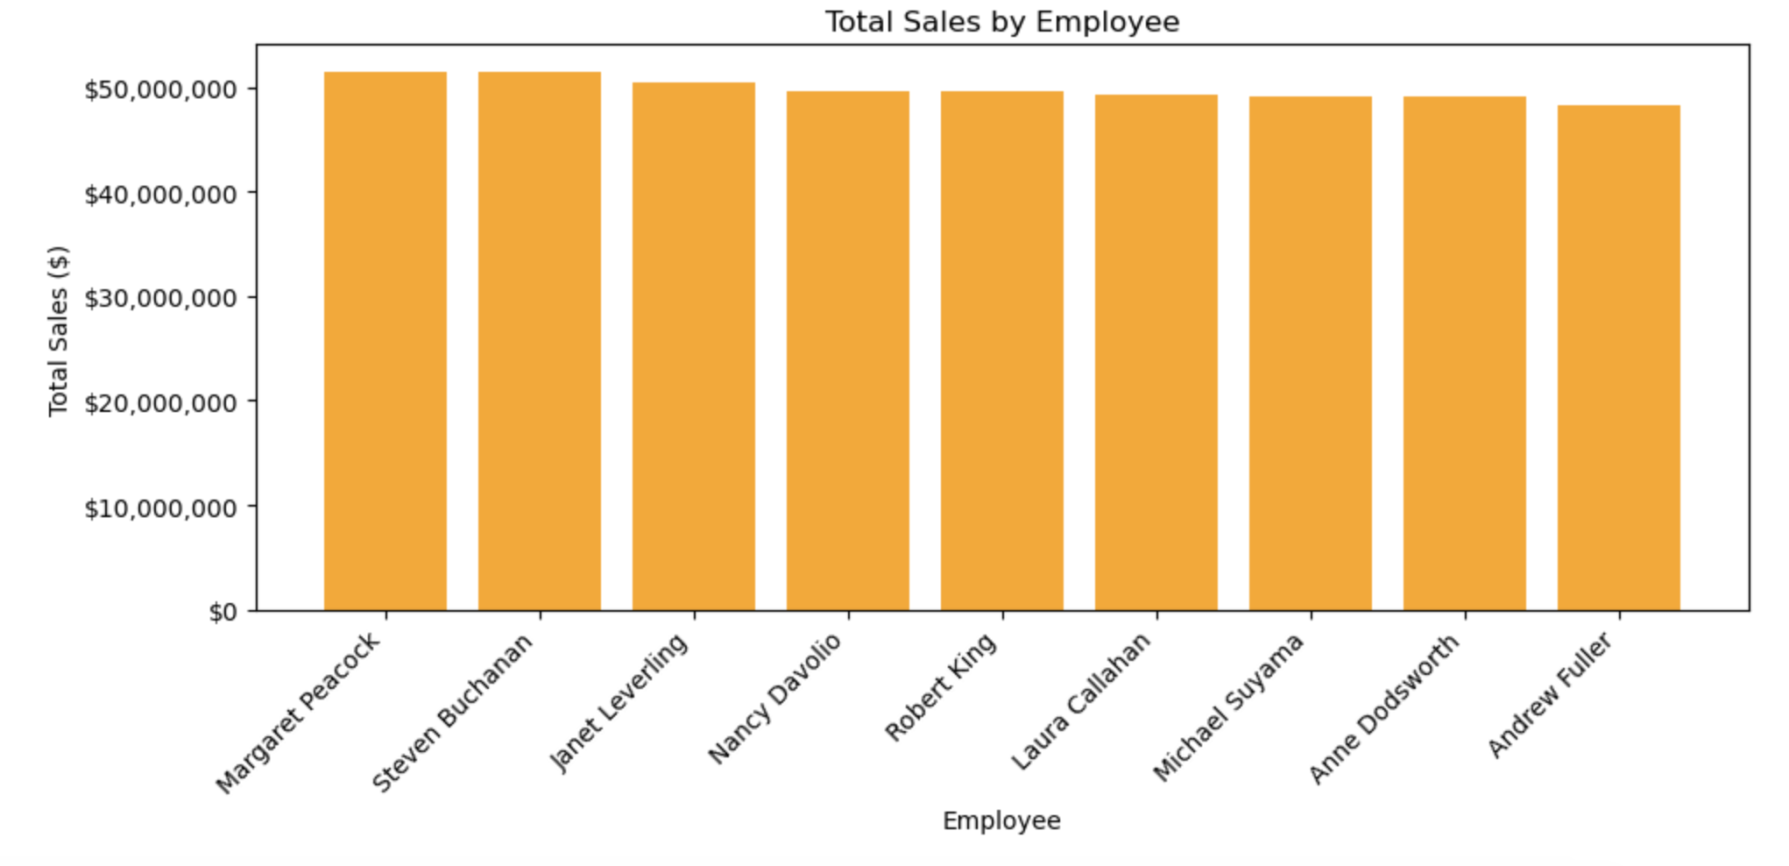

# **Part 2: Monthly Sales Trend Analysis**

We aggregated monthly sales from July 2012 to October 2023 by joining the Orders and Order Details tables to calculate revenue for each month. Month-over-month (MoM) growth was then calculated using SQLite window functions to highlight changes between consecutive months. The analysis reveals a clear seasonal pattern, with pronounced peaks in March, May, July, October, November, and December, often showing MoM growth between 21% and 48%. These months align with major holidays, while the months that follow typically see sharp declines of 21% to 31%. The consistent cycle of holiday-driven demand followed by post-holiday slowdowns suggests the need for targeted marketing, promotional campaigns, and inventory planning in advance of peak months, as well as strategies to sustain sales during slower periods.

**Method:** We executed the Phase 1 monthly sales query directly in Python against northwind.db, aggregating total monthly sales and calculating month-over-month growth using SQLite window functions. The output was saved as CSV, XLSX, and a PNG line graph.

**Insight:** The chart shows pronounced seasonal peaks in March, May, July, October, November, and December, often followed by sharp drops in the following months. This pattern reflects holiday demand cycles, suggesting that inventory and marketing efforts should be front-loaded ahead of these peak months.

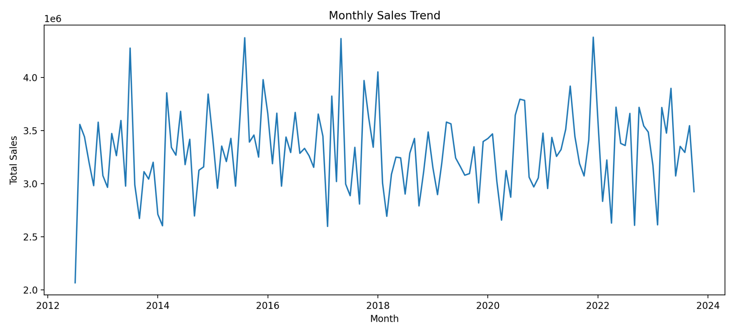

*Figure : Monthly Sales Trend (SQL + Python integration)*

# **Part 3: Product Sales Ranking by Category**

The SQL query determines the top-selling products within each category by calculating total sales for each product by multiplying unit price and quantity sold. The query then groups products by category, and ranks them using RANK() based on their total sales within each category. The top three best-selling products within each category are shown below.

**Method:**The Phase 1 product ranking query was run in Python, calculating total sales and units sold per product, and ranking them within each category using RANK(). The outputs were saved as CSV, XLSX, and a PNG bar chart.

**Insight:**In most categories, high-priced products lead in revenue despite not having the highest units sold, underscoring the importance of pricing strategy as well as volume. Promoting these high-margin items could improve profitability even if sales volume remains constant. This suggests that marketing campaigns, promotional bundles, and inventory planning should prioritise these products, particularly during peak sales months identified in the trend analysis.

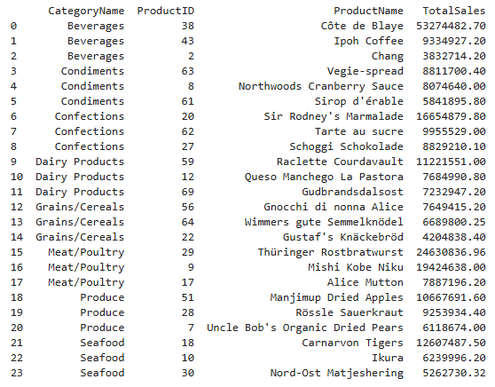

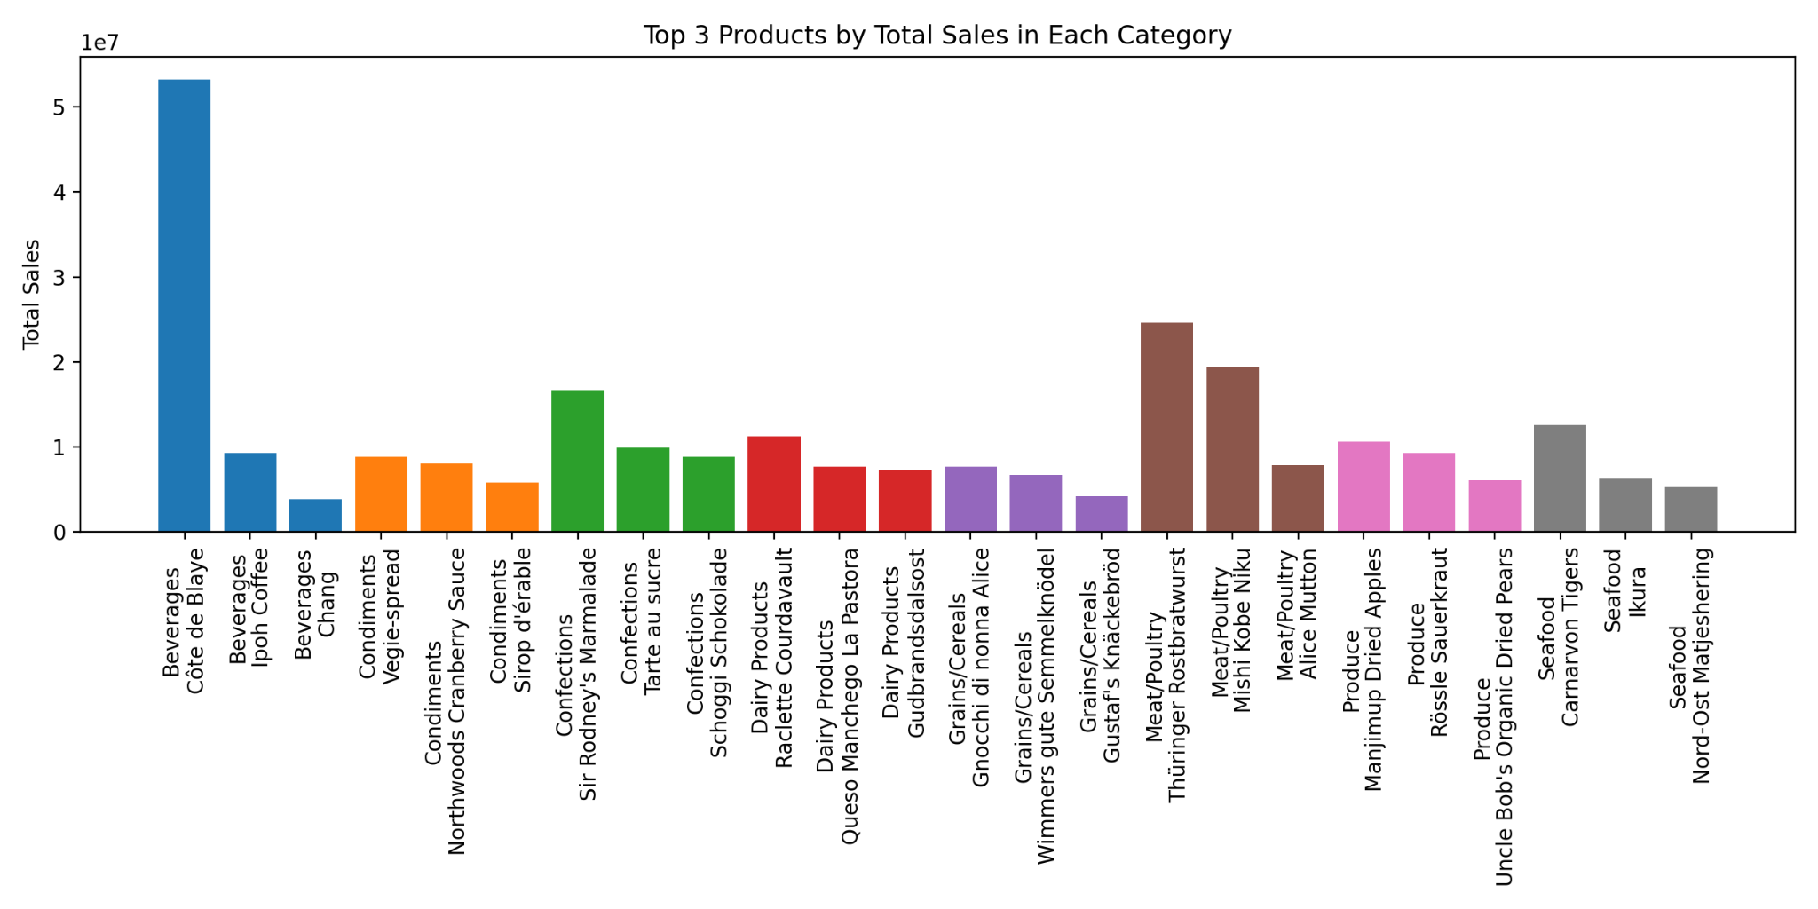

*Figure: Top 3 Products by Total Sales in Each Category (SQL + Python integration)*

*The SQL was executed in Python and outputs saved as CSV, XLSX, and PNG*

Analysis of monthly sales trends revealed consistent seasonal peaks in March, May, July, October, November, and December, followed by sharp post-holiday declines. These patterns indicate the need for targeted marketing and inventory ramp-ups ahead of high-demand periods, and strategic markdowns or cross-sell campaigns during slow months. Product ranking by category further showed that high-priced items often generate the most revenue despite lower unit volumes, highlighting the value of prioritising high-margin products in promotions. For Phase 3, the business should combine these insights into a seasonal sales calendar, align supply chain planning with peak demand, and focus promotional resources on top-margin products to maximise profitability year-round.

# **Part 4: Customer Purchase Behavior Analysis**

**Findings and Strategic Implications**

Analysis of Northwind’s customer metrics revealed that Fabrica Inter. Salchichas S.A. (FISSA) holds the highest average order value (AOV), yet none of the top ten customers by AOV appear in the top ten for either total revenue or total order count (see Appendix A-C). This contrast is notable when compared to B’s Beverages, which leads in both total revenue and order volume, but ranks significantly lower in AOV. Similarly, the top three customers for total revenue—B’s Beverages, Hungry Coyote Import Store, and Rancho Grande—rank 15th, 19th, and 20th in AOV respectively, while holding top-ten positions in total order count (1st, 6th, and 10th). This suggests two distinct customer segments: those driving value through fewer, high-value orders versus those generating value through frequent, lower-value transactions.

Particular focus was given to customers ranking 2nd, 3rd, 5th, 8th, 12th, 15th, and 17th in AOV. Most of these customers also maintain higher-than-average totals for both revenue and order count, with the exception of La corne d’abondance, which has lower total revenue than FISSA but matches its total orders at 155 (see Appendix D.). This dual metric perspective offers strategic opportunities: high-AOV customers can be nurtured with loyalty incentives and cross-sell promotions to increase order frequency, while high-volume, lower-AOV customers may benefit from targeted upsell strategies aimed at increasing per-order spend. By segmenting customer engagement strategies in this way, Northwind can better align marketing, sales, and product mix decisions to maximize both revenue and profitability across different customer profiles.

# **Conclusion**

# Our Phase 2 analysis combined SQL precision with Python visualisation to uncover patterns and relationships that go beyond surface level metrics. The employee performance review showed a team with balanced results where targeted sharing of top performer strategies and incentive based competition could lift the overall baseline.

The monthly sales trend analysis revealed a strong seasonal rhythm with consistent peaks before major holidays and predictable post peak dips, creating an opportunity to design a proactive, data backed sales calendar. Product sales ranking demonstrated that revenue leadership often comes from high margin items rather than high volume sellers, confirming that profitability depends as much on pricing and product mix as on sheer quantity sold. Customer behaviour analysis uncovered two distinct value driving groups: high AOV customers who buy less often but in large amounts, and high volume buyers who generate steady revenue but at lower margins. Each group requires tailored retention and upsell approaches.

When integrated, these insights point to a unified strategy: align inventory, staffing, and marketing with the seasonal cycle; focus promotions on high margin products during peak periods; and engage customer segments with personalized offers that match their buying patterns. By operationalising these data driven recommendations, Northwind can capture peak demand more effectively and sustain growth and profitability across the entire sales cycle.

# **Appendices**

**Appendix A: Top 10 Customers by Average Order Value (AOV)**

**Appendix B: Top 10 Customers by Total Revenue**

**Appendix C: Top 10 Customers by Total Order Count**

**Appendix D: Customers with AOV Ranks of Interest**

**Appendix E: Monthly Spend and MoM% Growth**

| **YearMonth** | **TotalSales** | **MoMGrowthPercent** |
| --- | --- | --- |
| **2012-07** | **2066219.4** |  |
| **2012-08** | **3556875.79** | **72.14** |
| **2012-09** | **3440144.98** | **-3.28** |
| **2012-10** | **3201529.96** | **-6.94** |
| **2012-11** | **2980494.74** | **-6.9** |
| **2012-12** | **3577936.85** | **20.05** |
| **2013-01** | **3075418.29** | **-14.04** |
| **2013-02** | **2964192.86** | **-3.62** |
| **2013-03** | **3471361.21** | **17.11** |
| **2013-04** | **3262893.52** | **-6.01** |
| **2013-05** | **3593528.01** | **10.13** |
| **2013-06** | **2976184.24** | **-17.18** |
| **2013-07** | **4275068.43** | **43.64** |
| **2013-08** | **2987993.36** | **-30.11** |
| **2013-09** | **2671413.23** | **-10.6** |
| **2013-10** | **3112262.1** | **16.5** |
| **2013-11** | **3042197.05** | **-2.25** |
| **2013-12** | **3200607.71** | **5.21** |
| **2014-01** | **2710443.83** | **-15.31** |
| **2014-02** | **2602658.47** | **-3.98** |
| **2014-03** | **3854314.06** | **48.09** |
| **2014-04** | **3340038.66** | **-13.34** |
| **2014-05** | **3267340.26** | **-2.18** |
| **2014-06** | **3680115.42** | **12.63** |
| **2014-07** | **3178414.39** | **-13.63** |
| **2014-08** | **3416670.63** | **7.5** |
| **2014-09** | **2694898.33** | **-21.13** |
| **2014-10** | **3125850.74** | **15.99** |
| **2014-11** | **3156916.6** | **0.99** |
| **2014-12** | **3842486.74** | **21.72** |
| **2015-01** | **3421656.38** | **-10.95** |
| **2015-02** | **2956201.14** | **-13.6** |
| **2015-03** | **3353227.79** | **13.43** |
| **2015-04** | **3207293.13** | **-4.35** |
| **2015-05** | **3425430.69** | **6.8** |
| **2015-06** | **2975668.32** | **-13.13** |
| **2015-07** | **3636472.82** | **22.21** |
| **2015-08** | **4372619.01** | **20.24** |
| **2015-09** | **3390593.89** | **-22.46** |
| **2015-10** | **3456874.61** | **1.95** |
| **2015-11** | **3249120.89** | **-6.01** |
| **2015-12** | **3978298.05** | **22.44** |
| **2016-01** | **3658051.75** | **-8.05** |
| **2016-02** | **3186904.49** | **-12.88** |
| **2016-03** | **3662692.07** | **14.93** |
| **2016-04** | **2975703.27** | **-18.76** |
| **2016-05** | **3437922.47** | **15.53** |
| **2016-06** | **3292493.54** | **-4.23** |
| **2016-07** | **3669700.165** | **11.46** |
| **2016-08** | **3284795.995** | **-10.49** |
| **2016-09** | **3331124.5** | **1.41** |
| **2016-10** | **3262160.375** | **-2.07** |
| **2016-11** | **3152849.905** | **-3.35** |
| **2016-12** | **3654273.83** | **15.9** |
| **2017-01** | **3446154.51** | **-5.7** |
| **2017-02** | **2596633.885** | **-24.65** |
| **2017-03** | **3823316.56** | **47.24** |
| **2017-04** | **3018989.7425** | **-21.04** |
| **2017-05** | **4364953.01** | **44.58** |
| **2017-06** | **2995440.2425** | **-31.38** |
| **2017-07** | **2885691.8075** | **-3.66** |
| **2017-08** | **3341024.17** | **15.78** |
| **2017-09** | **2807367.7525** | **-15.97** |
| **2017-10** | **3969991.476** | **41.41** |
| **2017-11** | **3618368.419** | **-8.86** |
| **2017-12** | **3341972.6585** | **-7.64** |
| **2018-01** | **4051026.5705** | **21.22** |
| **2018-02** | **3004052.9275** | **-25.84** |
| **2018-03** | **2691888.005** | **-10.39** |
| **2018-04** | **3087145.3625** | **14.68** |
| **2018-05** | **3248964.5605** | **5.24** |
| **2018-06** | **3242359.68** | **-0.2** |
| **2018-07** | **2901454.46** | **-10.51** |
| **2018-08** | **3286136.44** | **13.26** |
| **2018-09** | **3424899.45** | **4.22** |
| **2018-10** | **2789791.96** | **-18.54** |
| **2018-11** | **3113044.9** | **11.59** |
| **2018-12** | **3485859.11** | **11.98** |
| **2019-01** | **3151757.32** | **-9.58** |
| **2019-02** | **2895952.31** | **-8.12** |
| **2019-03** | **3190906.85** | **10.19** |
| **2019-04** | **3578994.95** | **12.16** |
| **2019-05** | **3562283.98** | **-0.47** |
| **2019-06** | **3241453.16** | **-9.01** |
| **2019-07** | **3163267.4** | **-2.41** |
| **2019-08** | **3078770.82** | **-2.67** |
| **2019-09** | **3093903.19** | **0.49** |
| **2019-10** | **3346327.82** | **8.16** |
| **2019-11** | **2817565.99** | **-15.8** |
| **2019-12** | **3395780.07** | **20.52** |
| **2020-01** | **3423774.29** | **0.82** |
| **2020-02** | **3467644.26** | **1.28** |
| **2020-03** | **3018709.85** | **-12.95** |
| **2020-04** | **2655472.57** | **-12.03** |
| **2020-05** | **3122293.71** | **17.58** |
| **2020-06** | **2871344.17** | **-8.04** |
| **2020-07** | **3643366.59** | **26.89** |
| **2020-08** | **3794089.55** | **4.14** |
| **2020-09** | **3783178.34** | **-0.29** |
| **2020-10** | **3060490.64** | **-19.1** |
| **2020-11** | **2968195.35** | **-3.02** |
| **2020-12** | **3053877.47** | **2.89** |
| **2021-01** | **3474864.06** | **13.79** |
| **2021-02** | **2953519.5** | **-15** |
| **2021-03** | **3434464.48** | **16.28** |
| **2021-04** | **3255793.01** | **-5.2** |
| **2021-05** | **3319860.71** | **1.97** |
| **2021-06** | **3510713.08** | **5.75** |
| **2021-07** | **3917400.08** | **11.58** |
| **2021-08** | **3443530.09** | **-12.1** |
| **2021-09** | **3186946.18** | **-7.45** |
| **2021-10** | **3071772.86** | **-3.61** |
| **2021-11** | **3408890.29** | **10.97** |
| **2021-12** | **4377795.4** | **28.42** |
| **2022-01** | **3591353.72** | **-17.96** |
| **2022-02** | **2832321.16** | **-21.13** |
| **2022-03** | **3222005.69** | **13.76** |
| **2022-04** | **2628034.83** | **-18.43** |
| **2022-05** | **3719270.11** | **41.52** |
| **2022-06** | **3378131.17** | **-9.17** |
| **2022-07** | **3358177.3** | **-0.59** |
| **2022-08** | **3660257.83** | **9** |
| **2022-09** | **2606755.13** | **-28.78** |
| **2022-10** | **3717586.61** | **42.61** |
| **2022-11** | **3542815.27** | **-4.7** |
| **2022-12** | **3485357.36** | **-1.62** |
| **2023-01** | **3171802.16** | **-9** |
| **2023-02** | **2611606.16** | **-17.66** |
| **2023-03** | **3716250.41** | **42.3** |
| **2023-04** | **3474940.3** | **-6.49** |
| **2023-05** | **3896544.35** | **12.13** |
| **2023-06** | **3071787.73** | **-21.17** |
| **2023-07** | **3350337.36** | **9.07** |
| **2023-08** | **3293158.67** | **-1.71** |
| **2023-09** | **3544698.51** | **7.64** |
| **2023-10** | **2923364.35** | **-17.53** |

**Appendix F: Total Sales vs MoM Growth**